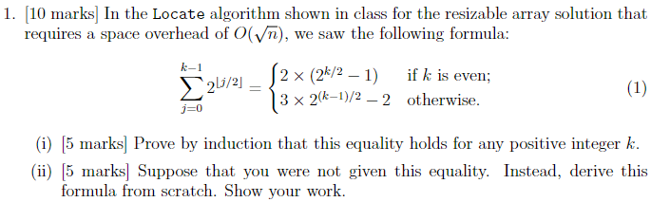

**Solution:**

Let’s try to derive the formula first:

**Solution (ii):**

Let us look at two approaches that DON’T work:

*Approach 1*:

Lets, try to store elements in $θ\left(\sqrt{n}\right)$ blocks, size of the largest block $θ\left(\sqrt{n}\right)$

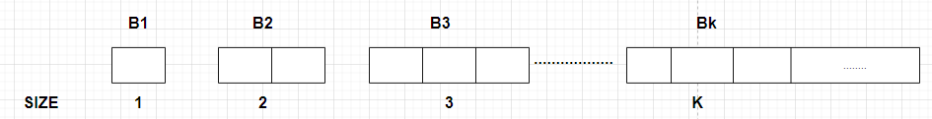

The total number of elements in the first k blocks is K(K+1)/2 = n

As $K^{2}+K-2n=0$ is a quadratic equation.

the total number of blocks k required to store n elements is $\left\lceil \left(\frac{\sqrt{1+8n}-1}{2}\right)\right\rceil$ this solves to $θ\left(\sqrt{n}\right)$

if we ignore the constants.

we are taking the ceil because the array supposed to have enough space under any case.

**Locate (i)**: The element **‘i’** is the $\left\lceil \left(\frac{\sqrt{1+8i}-1}{2}\right)\right\rceil$ block.

**We cannot go by this approach because the RAM does not support the computation of square root in O(1) time.**

*Approach 2*:

In order to negate the root. We can try doubling the block size each time and insert the data.

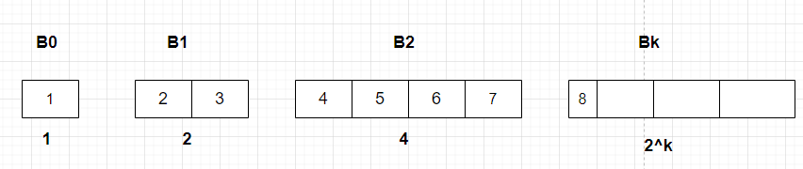

**Locate (i):**

Let’s see for the block number is related

|  |  |  |  |
| --- | --- | --- | --- |
| $$\dot{ⅈ}$$ | $$\dot{ⅈ}+1$$ | $${\left(\dot{ⅈ}+1\right)}_{2}$$ | Block Number |
| 0 | 1 | 01 | 0 |
| 1 | 2 | 10 | 1 |
| 2 | 3 | 11 | 1 |
| 3 | 4 | 100 | 2 |
| 4 | 5 | 101 | 2 |
| 5 | 6 | 110 | 2 |
| 6 | 7 | 111 | 2 |
| 7 | 8 | 1000 | 3 |

The block number is (the number of bits in binary expression of i+1) -1. Assuming that this can be calculated using the latest processors in constant time.

**The Issue here that the size of the largest block is easily $θ\left(n\right)$**

**Correct Approach:**

Taking both the failed approaches into consideration [1], the following model is constructed. 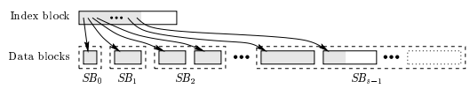

Figure 1: Generic snapshot of basic data structure [2].

**Concept:**

* Data blocks are grouped conceptually as super block
* All the data blocks within a superblock are of same size
* When a superblock is full it has $2^{\left\lfloor k∕2\right\rfloor }$ data blocks and each block contains $2^{\left\lceil k∕2\right\rceil }$, so, a super block contains $2^{\left\lfloor k∕2\right\rfloor }$ X $2^{\left\lceil k∕2\right\rceil }$ elements

**Locate (i):**

* The element ‘i’ is the element ‘e’ of the data block ‘b’ and superblock ‘k’
  + **K = |r| -1**
  + b is the $\left\lfloor k∕2\right\rfloor$ bits of r immediately after the leading 1-bit

Since the superblocks are conceptual we need to know how many data blocks are there in previous superblocks, knowing b and k does not suffice.

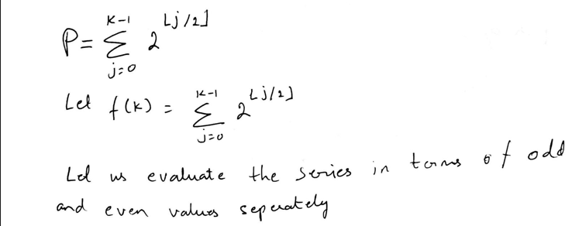

Even Series:

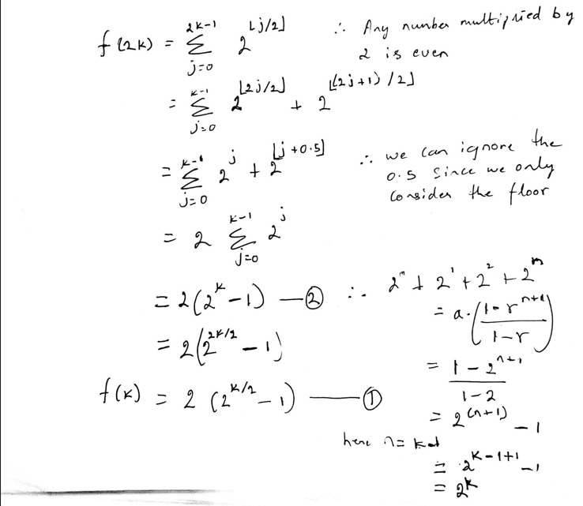

Odd Series:

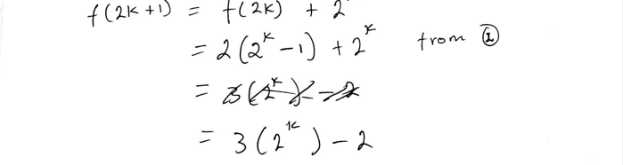 

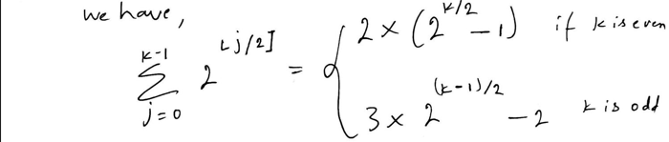

**Solution (i):**

**Prove by induction:**



